**Generative AI with AWS DeepComposer**

**What is AWS DeepComposer?**

AWS DeepComposer gives you a creative and easy way to get started with machine learning (ML), specifically generative AI. It consists of a **USB keyboard** that connects to your computer to input melody and the **AWS DeepComposer console**, which includes AWS DeepComposer Music studio to generate music, **learning capsules** to dive deep into generative AI models, and **AWS DeepComposer Chartbusters challenges** to showcase your ML skills.

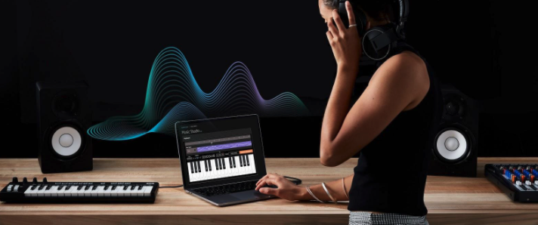

AWS DeepComposer

**Summary**

**AWS DeepComposer keyboard**

You don't need an AWS DeepComposer keyboard to finish this course. You can import your own MIDI file, use one of the provided sample melodies, or use the virtual keyboard in the AWS DeepComposer Music studio.

**AWS DeepComposer music studio**

To generate, create, and edit compositions with AWS DeepComposer, you use the AWS DeepComposer Music studio. To get started, you need an input track and a trained model.

For the *input track*, you can use a sample track, record a custom track, or import a track.

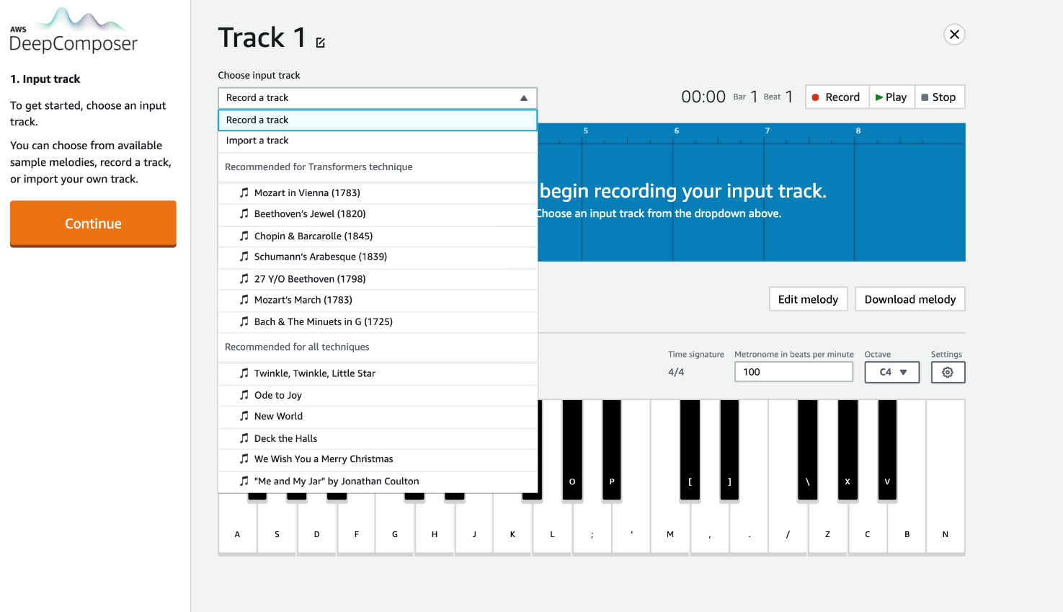

Input track

For the *ML technique*, you can use either a sample model or a custom model.

Each AWS DeepComposer Music studio experience supports three different generative AI techniques: generative adversarial networks (GANs), autoregressive convolutional neural network (AR-CNNs), and transformers.

* Use the GAN technique to create accompaniment tracks.
* Use the AR-CNN technique to modify notes in your input track.
* Use the transformers technique to extend your input track by up to 30 seconds.

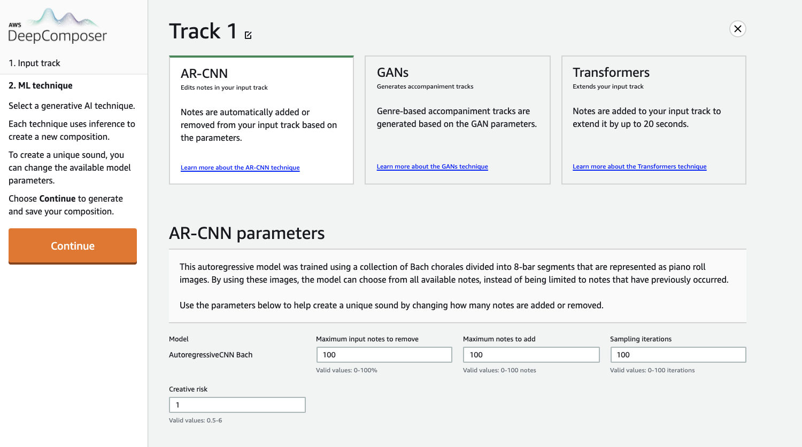

ML models

**Demo: AWS DeepComposer**

**Summary**

In this demo, you went through the AWS DeepComposer console where you can learn about deep learning, input your music, and train deep learning models to create new music.

**AWS DeepComposer learning capsules**

To learn the details behind generative AI and ML techniques used in AWS DeepComposer you can use easy-to-consume, bite-sized [learning capsules](https://console.aws.amazon.com/deepcomposer/home?region=us-east-1&utm_source=Udacity&utm_medium=Webpage&utm_campaign=Udacity%20AWS%20ML%20Foundations%20Course#learningCapsules) in the AWS DeepComposer console.

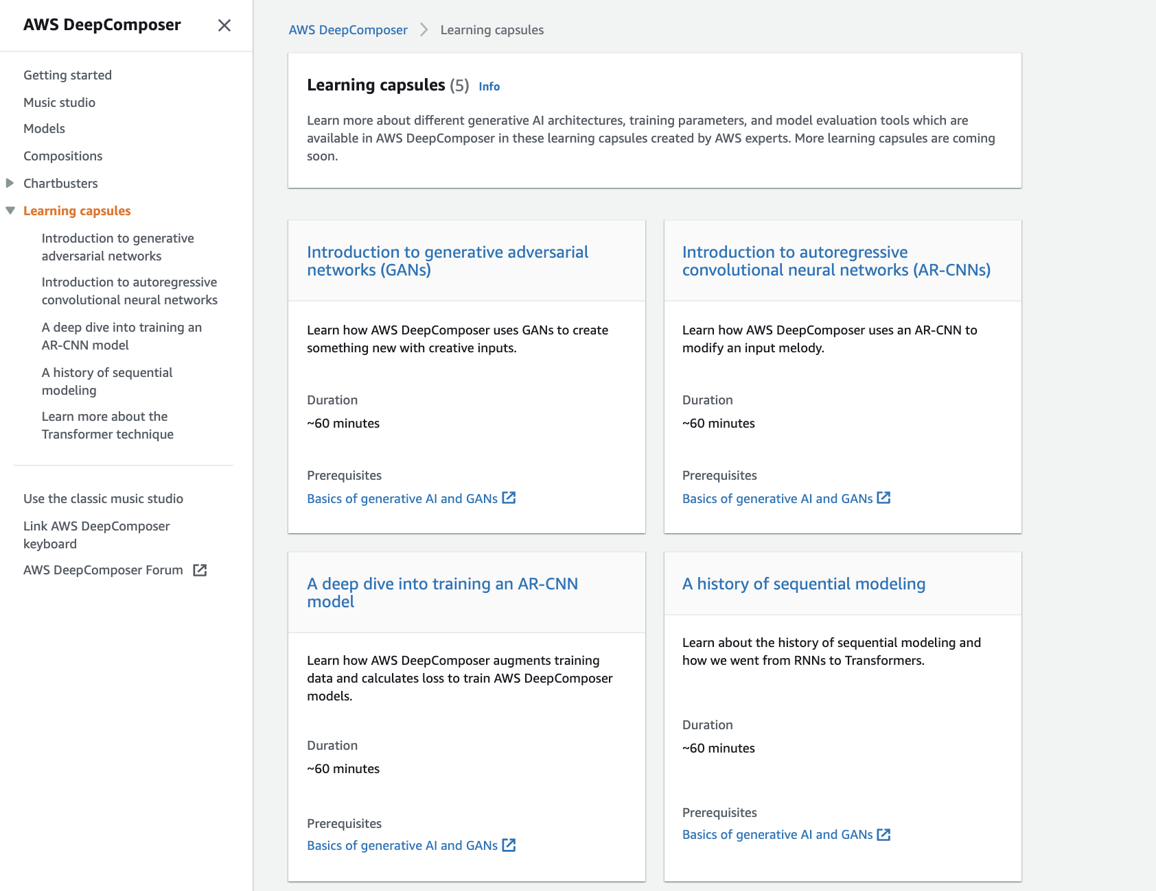

AWS DeepComposer learning capsules

**AWS DeepComposer Chartbusters challenges**

Chartbusters is a global challenge where you can use AWS DeepComposer to create original compositions and compete in monthly challenges to showcase your machine learning and generative AI skills.

You don't need to participate in this challenge to finish this course, but the course teaches everything you need to win in both challenges we launched this season. Regardless of your background in music or ML, you can find a competition just right for you.

You can choose between two different challenges this season:

* In the Basic challenge, “[Melody-Go-Round](https://console.aws.amazon.com/deepcomposer/home?region=us-east-1&utm_source=Udacity&utm_medium=Webpage&utm_campaign=Udacity%20AWS%20ML%20Foundations%20Course#chartbusters/basic)”, you can use any machine learning technique in the AWS DeepComposer Music studio to create new compositions.
* In the Advanced challenge, “[Melody Harvest](https://console.aws.amazon.com/deepcomposer/home?region=us-east-1&utm_source=Udacity&utm_medium=Webpage&utm_campaign=Udacity%20AWS%20ML%20Foundations%20Course#chartbusters/advanced)”, you train a custom generative AI model using Amazon SageMaker.

;